

PETROREP RESOURCES LTD.

1000,630 - 6th Avenue SW., Calgary, Alberta, Canada T2P OS8 ∙ Tel (403) 750-5100 Fax (403) 233-8344

June 30, 1999

**Re: Recommendation for William Nichols Consulting**

William Nichols Consulting was contracted by Petrorep to provide Exploitation, Reservoir, Production, Joint Interest and Acquisition Engineering services. I was very pleased with the results William Nichols Consulting provided. William Nichols is a very versatile engineer. He did an excellent job on all of the extremely varied assignments I gave him. These included everything from joint interest negotiations to waterflood optimization and simulation.

William's joint venture skills added significant value on a disposition project. He also acquired several small working interests for us that paid out in less than a year. His main contribution to Petrorep was a waterflood optimization and simulation study on our largest property. William devised a field development plan that increased reserves by over 750 mstb with a projected oil rate increase of 450 bopd. William's excellent reservoir engineering skills, painstaking attention to detail and hard work substantially increased the value of our largest property.

I highly recommend William Nichols Consulting for any petroleum engineering assignment.

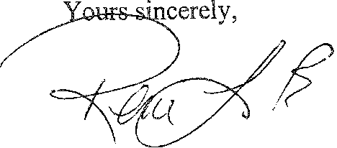

Rene LaPrade

Vice President, Operations Petrorep Resources Ltd.